Deploy In Kubernetes Cluster

|  |  |
| --- | --- |
| Team ID | PNT2022TMID42862 |
| Project Name | PERSONAL EXPENSE TRACKER |

Steps:

Create a Kubernetes cluster

* Sign in to your IBM Cloud Dashboard.
* Open IBM Kubernetes Service.
* Click Create Cluster.
* Select the Region where you want to deploy the cluster, type in a name for your

cluster,

* click Create Cluster.
* Select the appropriate cluster type depending on your account.
* It takes some time for the cluster to get ready (around 30 minutes).
* Once the cluster is ready, click on your cluster's name and you will be redirected to a

newpage with information about your cluster and worker node.

* + Click on the Worker Nodes tab to note the cluster’s Public IP

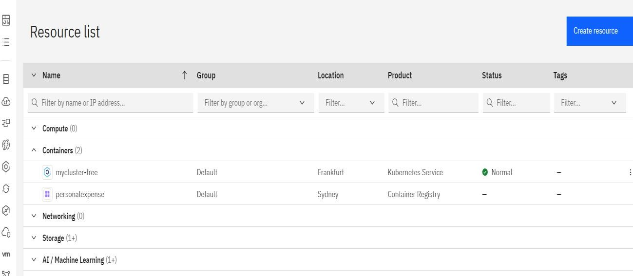

Click mycluster-free

**Create Cluster:**

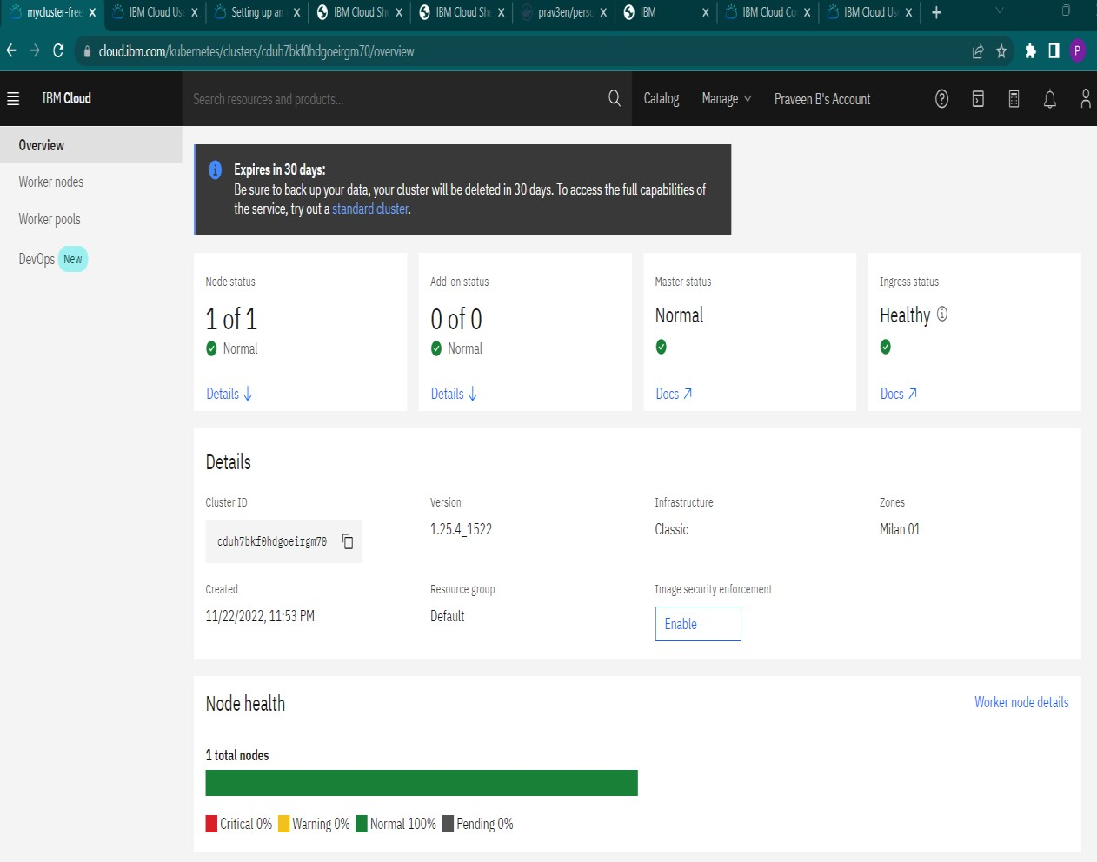

**Worker nodes status checking on Kubernetes:**

